1.
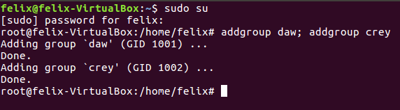
2.
3.
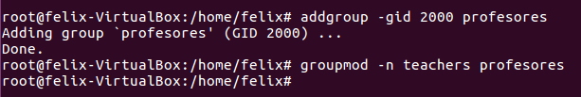
4.
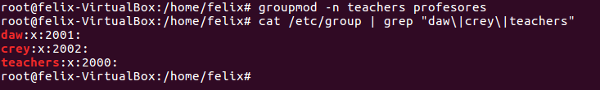
5.
The home directory is automatically created
6.
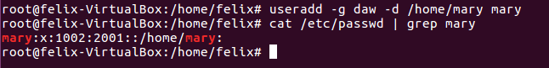
7.
Useradd –G crey,teachers –d /home/martha martha
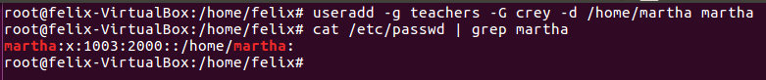
8.
9.
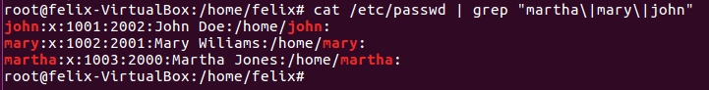
10.
11.

